<sol_start id=1>
1. (1) 3
<sol_end>

<sol_start id=2>
2. (3) Infinitely many solutions.
<sol_end>

<sol_start id=3>
3.
= 10
(1) 10 units
<sol_end>

<sol_start id=4>
4. (2) proportional
<sol_end>

<sol_start id=5>
5. (1)
<sol_end>

<sol_start id=6>
6. (1) x³ y³
<sol_end>

<sol_start id=7>
7. Let the roots be α & β , α + β = × β
2 =
4 =
16 = K – 4
<sol_end>

<sol_start id=8>
8. Let ABC be the equilateral triangle.
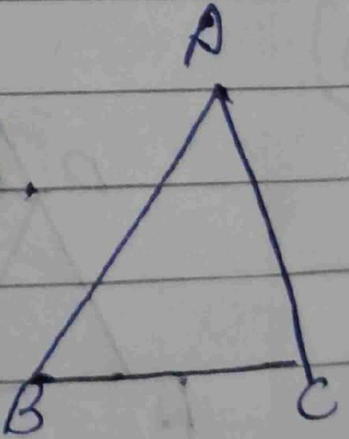
A = (0,0)
B =
AB =
=
=
=
AB = BC So.
BC
<sol_end>
<page_end>

<page_start no = 2>
<sol_start id=9>
9. no. solution =
So,
=
P =
∴ P can be any value thar then
So it be only one solution.
<sol_end>

<sol_start id=10>

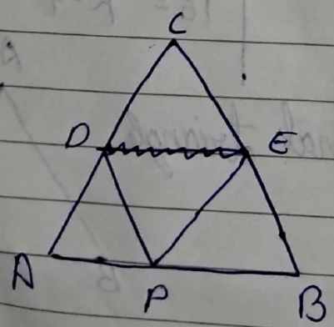
10.

PD||BC
Given → [BP T -(1)]
Also given → -(2)
From (1) & (2)
So
∴ PE||AC [Converse of BPT]
<sol_end>
<page_end>

<page_start no = 3>
<sol_start id=11>
11. tan θ =
To prove sin θ. cos θ =
<sol_end>

<sol_start id=12>
12.
<sol_end>

<sol_start id=13>
13. Let us assume is a national number.
ie = [where a & b are co - primes & b ≠ 0]
[squaring broth sides]
3b² = a²
3 divides a² → 3divides a also
i.e. a = 3c
3b² = (3c)²
b² = 3c²
∴ b² has none then one factions.
i.e. our assumption is wrong.
is an uri national number.
<sol_end>
<page_end>

<page_start no = 4>
<sol_start id=15>
15. 3x – (a + 1)y = 2b – 1
5x + (2 – 2a)y = 3b
Infinitely many solutions →
3 – 6a = –5a + 5
a + 2 = 0
a = 2
<sol_end>
<page_end>

<page_start no = 5>
<sol_start id=16>
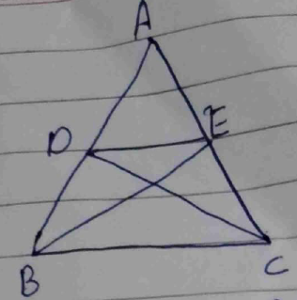
16.

Given ∆ABE ≅ ∆ACD
i.e. AB = AC [c.p.c.t]
also AD = AE -(1)
In ∆ADE & ∆ABC
CA = CA [common]
AD = DE [Fron (1)]
∴ ∆ABC & ∆ ADE [SAS similarity]
<sol_end>

<sol_start id=17>
17.
1 + tan² θ
<sol_end>

<sol_start id=18>
18. section formula →
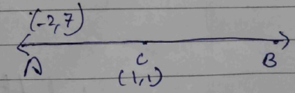
3x₂ – 4 = 5
3x₂ = a
x₂ =
x₂ = 3
3y₂ = 5 – 14
3y₂ = –9
y₂ = –3
therefore B = (3,-3)
<sol_end>
<page_end>

<page_start no = 6>
<sol_start id=19>
19. Let the numerator & denominator be x & y respectively
2x = y + 1
2x – y – 1 = 0 -(1)
Case (2)
= x – 4 – 2y
= x – 2y + 4 = 0 -(2)
(1)-(2)
2x – y – = 0 –1
–2x – 4y+ = 0 4
3y = –5
y =
substitute y = in eq. (2)
x – 2 = 4
x –
x = 4 +
x =
=
<sol_end>
<page_end>

<page_start no = 7>
<sol_start id=20>
20. Basic proportionality theorem →
If a line draw parallel to one under of the triangle
Given .
PR||BC
To prove
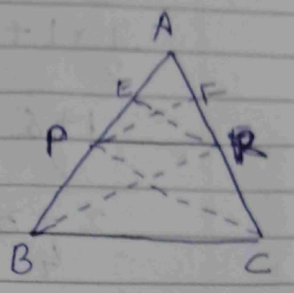
Construction → Draw PF & ER
Draw BR & PC
Proof Ar. ∆APR = × AP × ER -(1)
Ar. ∆BPE = × BP × ER -(2)
→
= -(3)
Ar. ∆ARP = × AR × PF -(4)
AR. ∆PRC = × CR × PE -(5)
→ -(6)
From (3) & (6)
<sol_end>
<page_end>

<page_start no = 8>
<sol_start id=21>
21.
=
=
=
=
=
=
<sol_end>

<sol_start id=22>
22. AB = CD [opposite sides]
Distance formula
= b
AB =
=
=
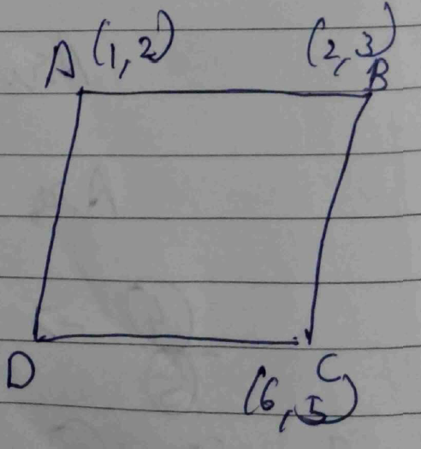
CD =
x² –12x + 36 + 25 + y² – 10y = 2
x² + y² + 61 – 12x – 10y = 2
<sol_end>

<sol_start id=23>
23. LCM of 330, 198 & 220
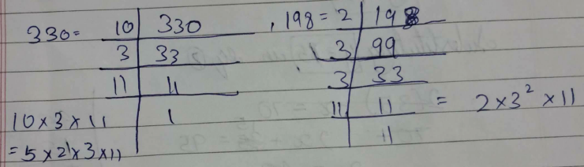
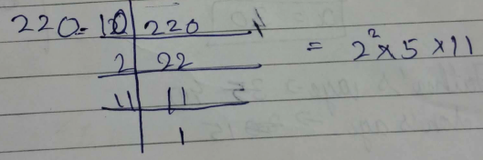
LCM (330,198,220) = 5¹ ×2² × 11 × 3²
= 5 × 4 × 11 × 9
= 1980 min.
After 33 hours they will be together.
<sol_end>

<sol_start id=24>
24. Let the father’s age be x & son’s age by y.
2y + x = 70 ----(1)
2x + y = 95 -----(2)
x + 2y = 70
x + y = 95
adding by (1) by (2)
3y = 45
y =
y = 15
superstition y = 15 in by (2)
2x +15 = 95
2x = 80
X = 40
Father’s age → 40
Son’s age → 15
<sol_end>
<page_end>

<page_start no = 9>
<sol_start id=25>
25. Section formula
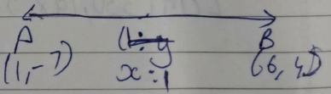
→
→ 1 (1) + x
<sol_end>

<sol_start id=26>
26. cosec θ – sin θ = m , sec θ – cos θ = n
<sol_end>

<sol_start id=27>
27. (i) 3 : 2
(ii) 15 miles
(iii)
(iv) 35 miles
<sol_end>
<page_end>

<page_start no = 10>
<sol_start id=28>
<sub_id = 1>
28. (i) Let (x₁,y₁) be (2,5)
(x₂,y₂) be (8,3)
ration → 1 : 2
section formula →
=
=
=
<sub_id end>
<sub_id = 2>
(ii) Distance formula →
Let (x₁ , y₁) be (2 , 5)
(x₂ , y₂) be (8 , 3)
units
<sub_id end>
<sub_id = 3>
(iii) 2 units
<sub_id end>
<sub_id = 4>
(iv) Multipoint formula →
=
=
= (5 , 4)
<sub_id end>
(II) tan θ =
=
= sin θ = ,cos θ
= sin² θ = , cos θ, sin θ
Tan θ =
1² + 2² = H²
1 + 4 = H²
5 = H²
H =
Sin θ =
=
Hence formula
<sol_end>
<page_end>

